Demographic Sentencing Disparities Baseline Switch
July 22, 2023
This document attempts to replicate the Commission’s “refined model” for estimating demographic disparities in sentencing. For more information about the model and for the reference regressions, see “Demographic Disparities Baseline Switch Reference Docs.” For a write-up of findings, see the latest version of the Data Learnings Memo.
SOURCES FILTER, BUT NO VAR-BASED NA FILTERS

White Male Baseline Regressions

Post-Protect
 | Estimate | Standard Error | t value | Pr(>|t|)
(Intercept) | 0.554 | 0.021 | 26.625 | 0.0000 | ***
logmin | 0.692 | 0.003 | 276.668 | 0.0000 | ***
drugtraffTRUE | 0.200 | 0.017 | 12.020 | 0.0000 | ***
sexual2TRUE | 0.165 | 0.065 | 2.559 | 0.0105 | *
pornTRUE | 0.196 | 0.051 | 3.809 | 0.0001 | ***
immigrationTRUE | 0.168 | 0.021 | 7.834 | 0.0000 | ***
othtypeTRUE | -0.428 | 0.030 | -14.185 | 0.0000 | ***
whitecollTRUE | -0.366 | 0.019 | -18.838 | 0.0000 | ***
upwardTRUE | 1.064 | 0.056 | 18.974 | 0.0000 | ***
downdepTRUE | -0.905 | 0.016 | -54.869 | 0.0000 | ***
subasstTRUE | -1.177 | 0.016 | -74.933 | 0.0000 | ***
mandmin2 | 0.105 | 0.018 | 5.830 | 0.0000 | ***
NEWCNVTN | 0.257 | 0.025 | 10.151 | 0.0000 | ***
custody | 0.750 | 0.014 | 55.517 | 0.0000 | ***
relevel(factor(racesex), ref = 8)blackfemale | -0.426 | 0.029 | -14.818 | 0.0000 | ***
relevel(factor(racesex), ref = 8)blackmale | 0.086 | 0.016 | 5.509 | 0.0000 | ***
relevel(factor(racesex), ref = 8)hispfemale | -0.283 | 0.030 | -9.580 | 0.0000 | ***
relevel(factor(racesex), ref = 8)hispmale | -0.012 | 0.017 | -0.713 | 0.4758
relevel(factor(racesex), ref = 8)otherfemale | -0.556 | 0.059 | -9.465 | 0.0000 | ***
relevel(factor(racesex), ref = 8)othermale | -0.063 | 0.031 | -2.023 | 0.0430 | *
relevel(factor(racesex), ref = 8)whitefemale | -0.285 | 0.025 | -11.464 | 0.0000 | ***
agedummyTRUE | 0.039 | 0.013 | 3.095 | 0.0020 | **
educTRUE | -0.061 | 0.014 | -4.443 | 0.0000 | ***
citizen | 0.019 | 0.016 | 1.139 | 0.2549
Signif. codes: 0 <= '***' < 0.001 < '**' < 0.01 < '*' < 0.05
Residual standard error: 1.327 on 66139 degrees of freedom
Multiple R-squared: 0.7073, Adjusted R-squared: 0.7072
F-statistic: 6948 on 66139 and 23 DF, p-value: 0.0000

Post-Booker
 | Estimate | Standard Error | t value | Pr(>|t|)
(Intercept) | 0.414 | 0.016 | 26.025 | 0.0000 | ***
logmin | 0.699 | 0.002 | 356.179 | 0.0000 | ***
drugtraffTRUE | 0.221 | 0.012 | 18.280 | 0.0000 | ***
sexual2TRUE | 0.122 | 0.044 | 2.755 | 0.0059 | **
pornTRUE | 0.448 | 0.029 | 15.173 | 0.0000 | ***
immigrationTRUE | 0.159 | 0.015 | 10.388 | 0.0000 | ***
othtypeTRUE | -0.438 | 0.022 | -19.961 | 0.0000 | ***
whitecollTRUE | -0.308 | 0.014 | -21.450 | 0.0000 | ***
upwardTRUE | 0.982 | 0.030 | 33.270 | 0.0000 | ***
downdepTRUE | -0.899 | 0.009 | -96.079 | 0.0000 | ***
subasstTRUE | -1.084 | 0.012 | -90.889 | 0.0000 | ***
mandmin2 | 0.190 | 0.012 | 15.449 | 0.0000 | ***
NEWCNVTN | 0.323 | 0.018 | 18.254 | 0.0000 | ***
custody | 0.773 | 0.010 | 77.685 | 0.0000 | ***
relevel(factor(racesex), ref = 8)blackfemale | -0.303 | 0.022 | -13.896 | 0.0000 | ***
relevel(factor(racesex), ref = 8)blackmale | 0.159 | 0.011 | 13.975 | 0.0000 | ***
relevel(factor(racesex), ref = 8)hispfemale | -0.281 | 0.021 | -13.599 | 0.0000 | ***
relevel(factor(racesex), ref = 8)hispmale | -0.001 | 0.013 | -0.102 | 0.9189
relevel(factor(racesex), ref = 8)otherfemale | -0.319 | 0.040 | -7.919 | 0.0000 | ***
relevel(factor(racesex), ref = 8)othermale | 0.039 | 0.021 | 1.815 | 0.0695 | .
relevel(factor(racesex), ref = 8)whitefemale | -0.226 | 0.018 | -12.375 | 0.0000 | ***
agedummyTRUE | 0.038 | 0.009 | 4.013 | 0.0001 | ***
educTRUE | -0.052 | 0.010 | -5.270 | 0.0000 | ***
citizen | 0.071 | 0.012 | 6.032 | 0.0000 | ***
Signif. codes: 0 <= '***' < 0.001 < '**' < 0.01 < '*' < 0.05
Residual standard error: 1.352 on 134989 degrees of freedom
Multiple R-squared: 0.6703, Adjusted R-squared: 0.6703
F-statistic: 1.193e+04 on 134989 and 23 DF, p-value: 0.0000

Post-Gall
 | Estimate | Standard Error | t value | Pr(>|t|)
(Intercept) | 0.417 | 0.013 | 31.003 | 0.0000 | ***
logmin | 0.633 | 0.001 | 422.162 | 0.0000 | ***
drugtraffTRUE | 0.176 | 0.010 | 17.576 | 0.0000 | ***
sexual2TRUE | 0.202 | 0.037 | 5.464 | 0.0000 | ***
pornTRUE | 0.599 | 0.021 | 28.299 | 0.0000 | ***
immigrationTRUE | 0.143 | 0.012 | 11.548 | 0.0000 | ***
othtypeTRUE | -0.651 | 0.018 | -36.211 | 0.0000 | ***
whitecollTRUE | -0.327 | 0.012 | -27.327 | 0.0000 | ***
upwardTRUE | 0.881 | 0.021 | 41.070 | 0.0000 | ***
downdepTRUE | -0.969 | 0.007 | -138.099 | 0.0000 | ***
subasstTRUE | -1.011 | 0.010 | -99.500 | 0.0000 | ***
mandmin2 | 0.415 | 0.010 | 41.878 | 0.0000 | ***
NEWCNVTN | 0.408 | 0.016 | 25.414 | 0.0000 | ***
custody | 0.960 | 0.008 | 115.625 | 0.0000 | ***
relevel(factor(racesex), ref = 8)blackfemale | -0.402 | 0.019 | -21.396 | 0.0000 | ***
relevel(factor(racesex), ref = 8)blackmale | 0.186 | 0.010 | 19.533 | 0.0000 | ***
relevel(factor(racesex), ref = 8)hispfemale | -0.207 | 0.016 | -12.784 | 0.0000 | ***
relevel(factor(racesex), ref = 8)hispmale | 0.014 | 0.010 | 1.431 | 0.1525
relevel(factor(racesex), ref = 8)otherfemale | -0.429 | 0.035 | -12.288 | 0.0000 | ***
relevel(factor(racesex), ref = 8)othermale | 0.002 | 0.018 | 0.129 | 0.8973
relevel(factor(racesex), ref = 8)whitefemale | -0.383 | 0.015 | -25.943 | 0.0000 | ***
agedummyTRUE | 0.037 | 0.008 | 4.860 | 0.0000 | ***
educTRUE | -0.061 | 0.008 | -7.518 | 0.0000 | ***
citizen | 0.091 | 0.010 | 9.499 | 0.0000 | ***
Signif. codes: 0 <= '***' < 0.001 < '**' < 0.01 < '*' < 0.05
Residual standard error: 1.497 on 264887 degrees of freedom
Multiple R-squared: 0.6004, Adjusted R-squared: 0.6003
F-statistic: 1.73e+04 on 264887 and 23 DF, p-value: 0.0000

Post-Report
 | Estimate | Standard Error | t value | Pr(>|t|)
(Intercept) | 0.158 | 0.014 | 11.551 | 0.0000 | ***
logmin | 0.621 | 0.001 | 419.358 | 0.0000 | ***
drugtraffTRUE | 0.203 | 0.010 | 21.015 | 0.0000 | ***
sexual2TRUE | 0.254 | 0.030 | 8.344 | 0.0000 | ***
pornTRUE | 0.650 | 0.019 | 33.409 | 0.0000 | ***
immigrationTRUE | -0.011 | 0.012 | -0.929 | 0.3527
othtypeTRUE | -0.553 | 0.017 | -31.848 | 0.0000 | ***
whitecollTRUE | -0.183 | 0.012 | -15.885 | 0.0000 | ***
upwardTRUE | 0.684 | 0.020 | 34.400 | 0.0000 | ***
downdepTRUE | -1.043 | 0.007 | -154.955 | 0.0000 | ***
subasstTRUE | -1.091 | 0.010 | -108.041 | 0.0000 | ***
mandmin2 | 0.486 | 0.010 | 49.494 | 0.0000 | ***
NEWCNVTN | 0.509 | 0.017 | 30.641 | 0.0000 | ***
custody | 1.331 | 0.008 | 161.712 | 0.0000 | ***
relevel(factor(racesex), ref = 8)blackfemale | -0.350 | 0.018 | -19.273 | 0.0000 | ***
relevel(factor(racesex), ref = 8)blackmale | 0.184 | 0.010 | 19.145 | 0.0000 | ***
relevel(factor(racesex), ref = 8)hispfemale | -0.183 | 0.015 | -12.197 | 0.0000 | ***
relevel(factor(racesex), ref = 8)hispmale | 0.055 | 0.010 | 5.564 | 0.0000 | ***
relevel(factor(racesex), ref = 8)otherfemale | -0.452 | 0.032 | -14.246 | 0.0000 | ***
relevel(factor(racesex), ref = 8)othermale | -0.045 | 0.017 | -2.606 | 0.0092 | **
relevel(factor(racesex), ref = 8)whitefemale | -0.356 | 0.015 | -24.468 | 0.0000 | ***
agedummyTRUE | 0.027 | 0.008 | 3.426 | 0.0006 | ***
educTRUE | -0.008 | 0.008 | -1.019 | 0.3081
citizen | 0.050 | 0.010 | 5.218 | 0.0000 | ***
Signif. codes: 0 <= '***' < 0.001 < '**' < 0.01 < '*' < 0.05
Residual standard error: 1.623 on 326917 degrees of freedom
Multiple R-squared: 0.5654, Adjusted R-squared: 0.5654
F-statistic: 1.85e+04 on 326917 and 23 DF, p-value: 0.0000

Present
 | Estimate | Standard Error | t value | Pr(>|t|)
(Intercept) | 0.120 | 0.017 | 6.967 | 0.0000 | ***
logmin | 0.492 | 0.002 | 283.610 | 0.0000 | ***
drugtraffTRUE | 0.274 | 0.012 | 23.761 | 0.0000 | ***
sexual2TRUE | 0.434 | 0.036 | 11.969 | 0.0000 | ***
pornTRUE | 0.793 | 0.024 | 32.828 | 0.0000 | ***
immigrationTRUE | -0.291 | 0.015 | -19.941 | 0.0000 | ***
othtypeTRUE | -0.580 | 0.022 | -26.536 | 0.0000 | ***
whitecollTRUE | -0.107 | 0.015 | -7.253 | 0.0000 | ***
upwardTRUE | 0.740 | 0.022 | 32.957 | 0.0000 | ***
downdepTRUE | -1.000 | 0.008 | -119.873 | 0.0000 | ***
subasstTRUE | -0.890 | 0.014 | -64.781 | 0.0000 | ***
mandmin2 | 0.698 | 0.012 | 58.234 | 0.0000 | ***
NEWCNVTN | 0.621 | 0.023 | 26.810 | 0.0000 | ***
custody | 1.725 | 0.010 | 167.408 | 0.0000 | ***
relevel(factor(racesex), ref = 8)blackfemale | -0.599 | 0.025 | -23.759 | 0.0000 | ***
relevel(factor(racesex), ref = 8)blackmale | 0.167 | 0.012 | 13.921 | 0.0000 | ***
relevel(factor(racesex), ref = 8)hispfemale | -0.144 | 0.018 | -7.912 | 0.0000 | ***
relevel(factor(racesex), ref = 8)hispmale | 0.116 | 0.013 | 9.057 | 0.0000 | ***
relevel(factor(racesex), ref = 8)otherfemale | -0.573 | 0.040 | -14.442 | 0.0000 | ***
relevel(factor(racesex), ref = 8)othermale | -0.058 | 0.022 | -2.668 | 0.0076 | **
relevel(factor(racesex), ref = 8)whitefemale | -0.425 | 0.019 | -22.314 | 0.0000 | ***
agedummyTRUE | 0.083 | 0.010 | 8.316 | 0.0000 | ***
educTRUE | -0.025 | 0.010 | -2.562 | 0.0104 | *
citizen | 0.046 | 0.012 | 3.893 | 0.0001 | ***
Signif. codes: 0 <= '***' < 0.001 < '**' < 0.01 < '*' < 0.05
Residual standard error: 1.694 on 235253 degrees of freedom
Multiple R-squared: 0.5308, Adjusted R-squared: 0.5308
F-statistic: 1.157e+04 on 235253 and 23 DF, p-value: 0.0000

Demographic Disparities in Sentencing: Bar Graphs

White Male Baseline
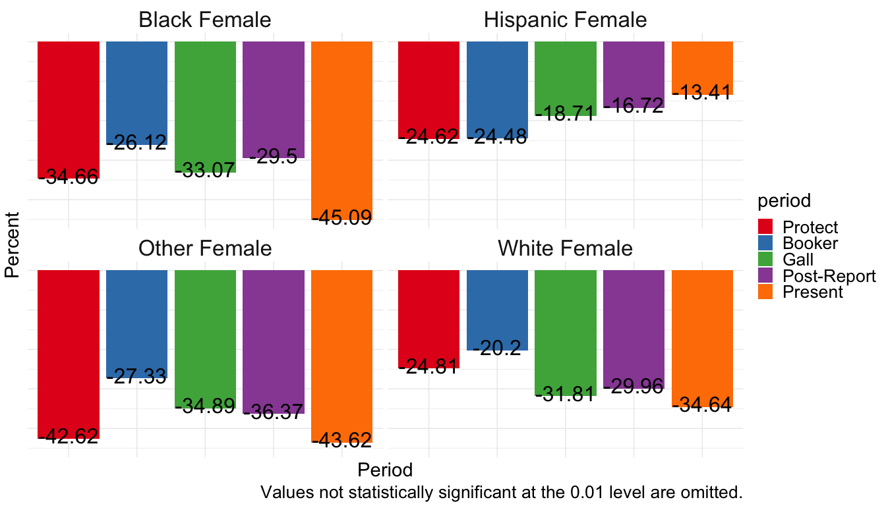
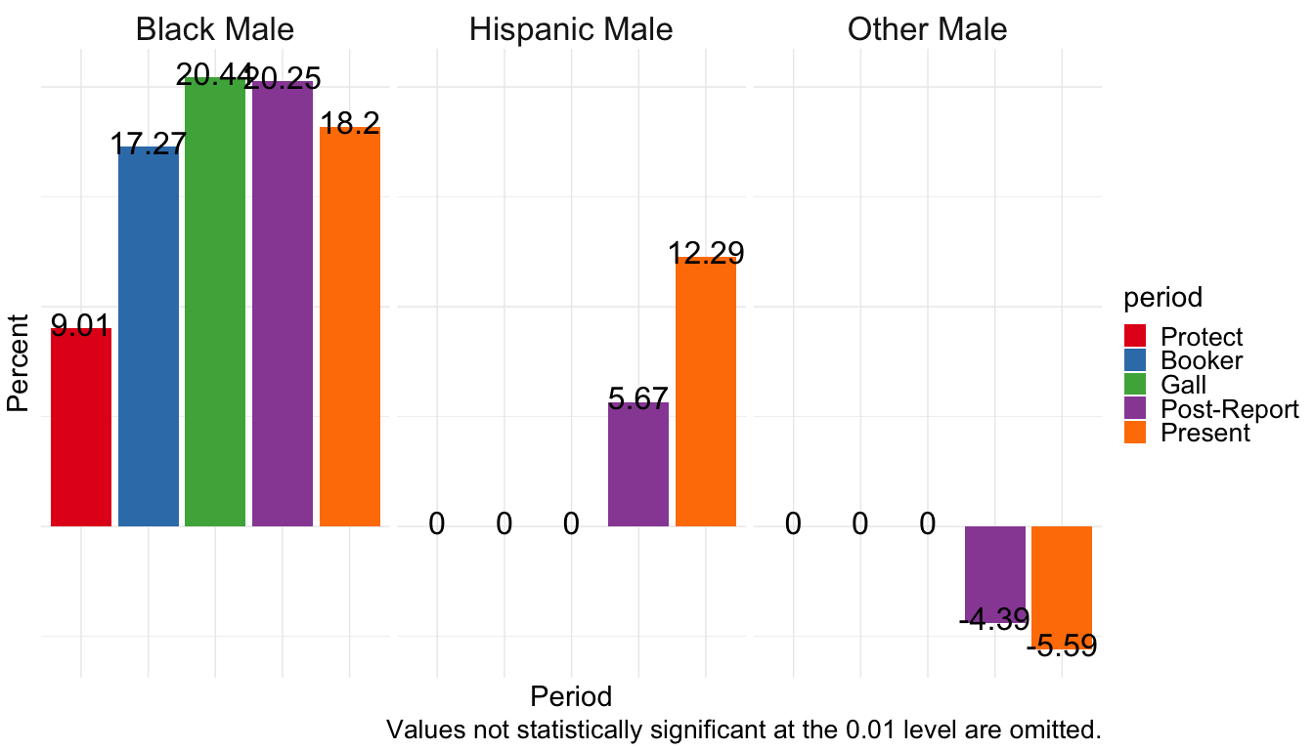

White Female Baseline
Note the colors are scrambled slightly where no statistically significant difference in groups exists during the Protect period.
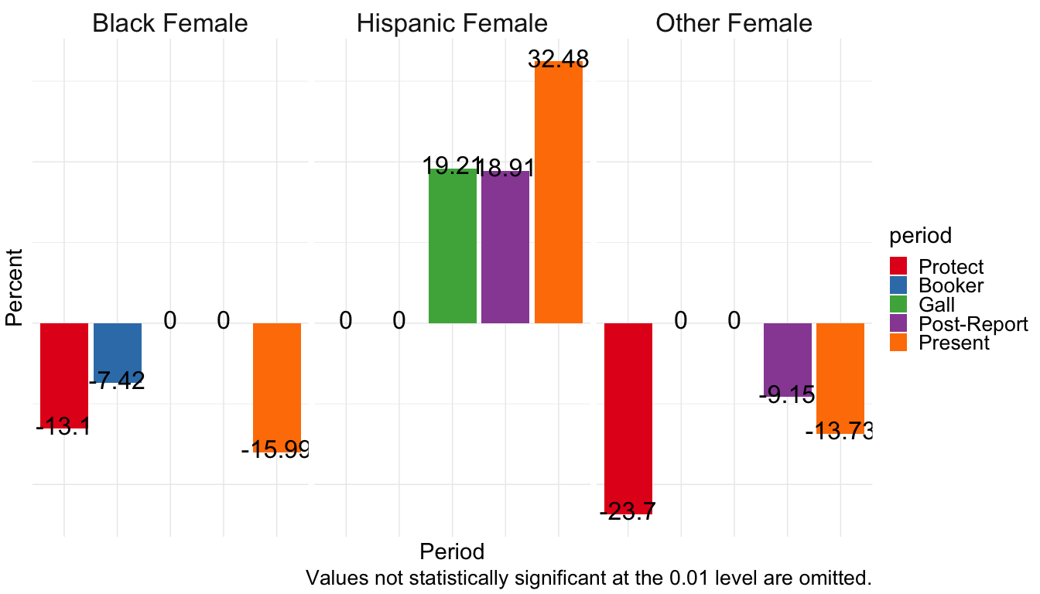
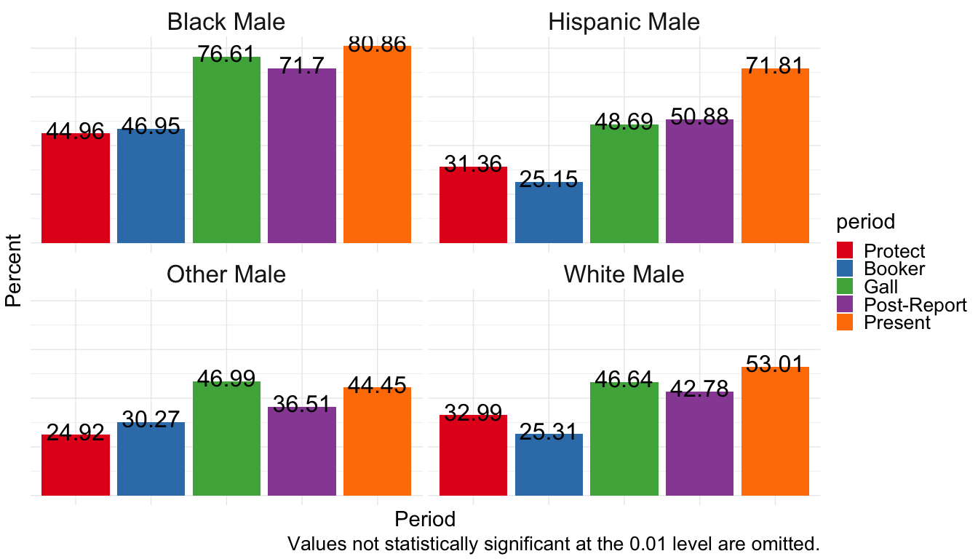

Hispanic Female Baseline
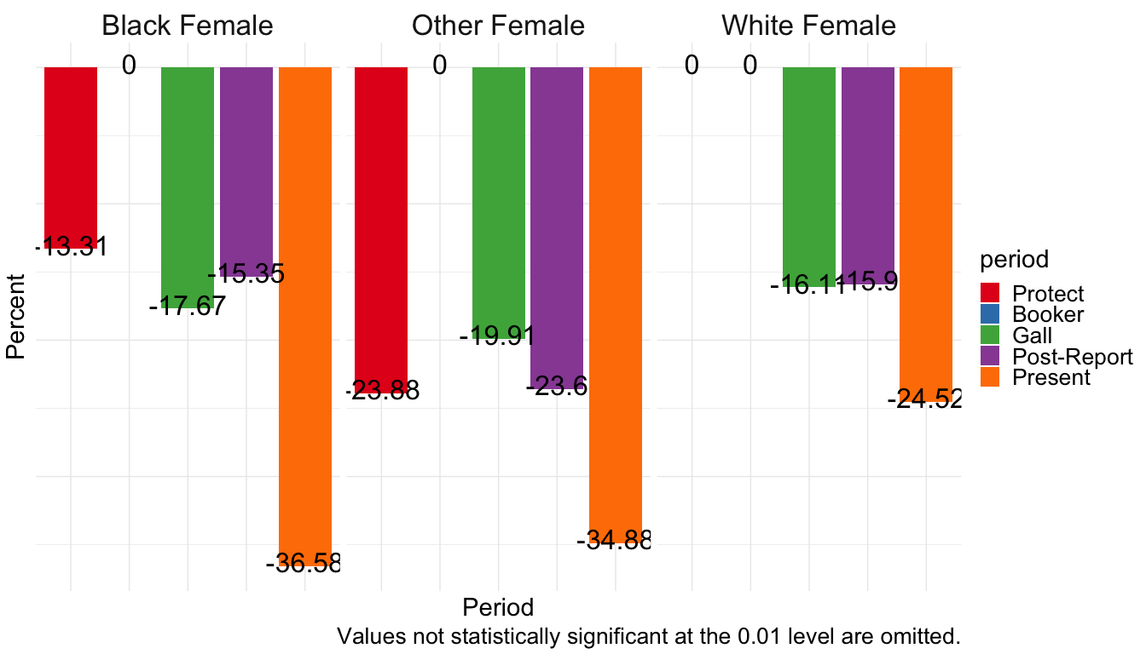
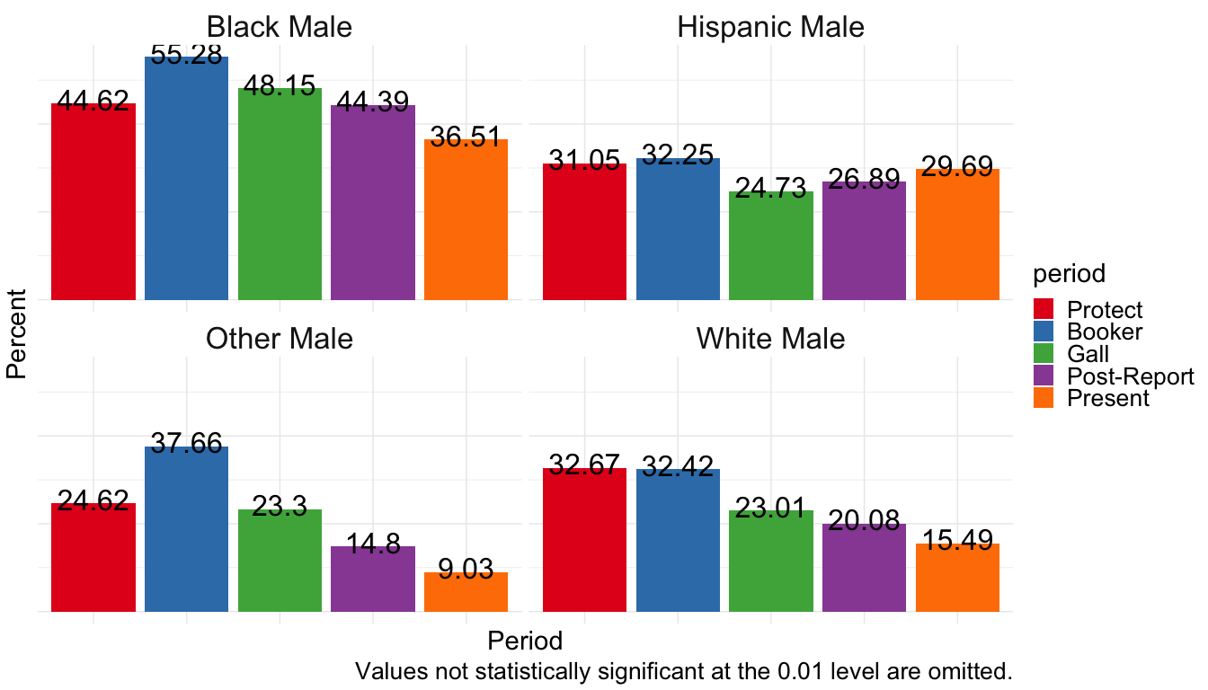

Black Female Baseline
